Question One Marks
a) | Find 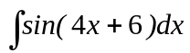. |  | 1
b) | Differentiate 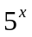. |  | 1
c) | For what values of x will  have a limiting sum for 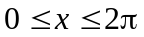. |  | 4
d) | The sketch of the curve of 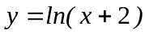 is shown below.  If the shaded area is rotated about the y-axis, find the volume of revolution of the solid generated.  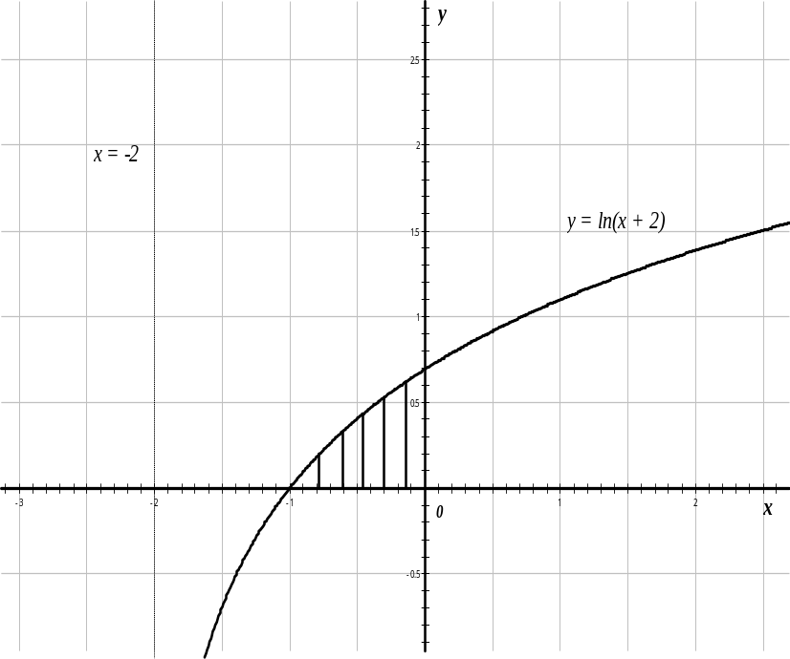 |  | 4
Question Two (Start a New Page)
a) i) | Express 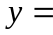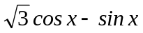 in the form of 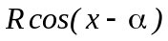,  where 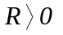and 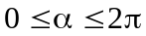. |  | 3
ii) | Sketch the graph of , for 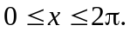 |  | 3
b) i) | Differentiate 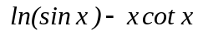. |  | 2
ii) | Hence find 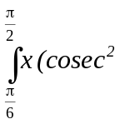x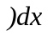. |  | 2
Question Three (Start a New Page) |  |  | Marks
a) | Prove that 2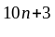+ 3 is divisible by 11 for all non-negative integers n by Mathematical Induction. |  | 5
b) | A spherical map of the earth is being inflated at a constant rate of 25cms. Find the rate at which the length of the equator is changing when the radius is 10cm. |  | 5
Question Four (Start a New Page)
a) Differentiate 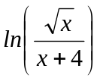. |  | 2
b) Consider the function 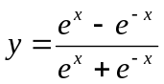,

i) | Prove that y has no stationary points. | 2
ii) | Prove that the lines y=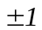 are asymptotes. | 2
iii) | If k is a positive constant, find the area in the first quadrant enclosed by the above curve and the three lines y=1, x= 0 and x= k. | 3
iv) | Prove that for all values of k, the area is always less than ln 2. | 1
Question Five (Start a New Page)
a) | Find 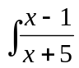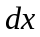. | 2
b) | Evaluate 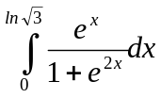. | 3
c) | Amy borrows $130 000 to start a sign writing business. Interest is charged on the balance owing at the rate of 9% per annum, compounded monthly. Amy agrees to repay the loan, including interest, by making equal monthly instalment of $P.
i) | How much does Amy owe at the end of the first month just before she makes an instalment payment? | 1
Question Five cont’d |  | Marks
c) ii) | Show that if the loan is repaid after n months, then  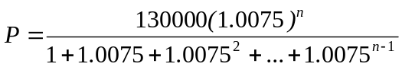. | 1
iii) | Calculate how many months, to the nearest month, it will take for the loan to be repaid if Amy makes instalments of $1800 per month. | 3
Question Six (Start a New Page)
a) | Using the substitution 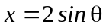, show by integration that  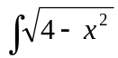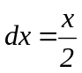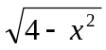+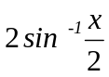+ C, where C is a constant. | 4
b) | A rectangular paddock in a vineyard measures 90m by 120m. In order to make best use of the sun, the grape vines are planted in diagonal rows as shown, with a 3 metre gap between adjacent rows.  90 m  R  R  R  R  R  Diagram not to scale  3m  120 m
i) | Find the length of R, the diagonal of the field. | 1
ii) | Show that length of the R is 143.75 m. | 2
iii) | Given that the rows R+ R+ R+R+… form an arithmetic series, find the total number of rows of vines in the paddock. | 3
 | END OF PAPER

